Name : Soham Kishor Kulthe

Module : Fund SQL

Batch : 12pm-2pm

Batch coordinator: Nidhi Bhat

Topic : College Commerce Course Management System Database

InTROduCTION

Here I have made a structured data of Commerce Course which belongs to a particular college where, all the data from the commerce course is organized in a structured manner . The events held in the college like fests and sports day are recorded and the records belong to the students who belongs to the commerce background.

Three tables are made –

* Table 1- Commerce_course - This table includes details of the students belonging to commerce background where all the records like name ,course,course fees,student ID etc is recorded.
* Table-2- Fests – This table includes data of the students who have participated in different fests.
* Table-3- Sports day- This table includes data of the students who have participated in different sports.

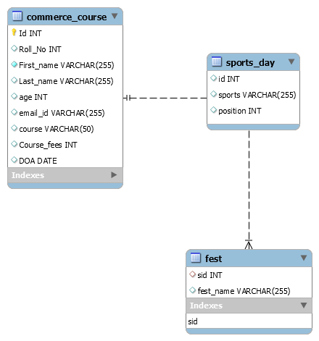ER DIGRAM

Creating database college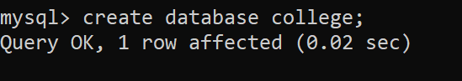

Creating table commerce course

Describing commerce course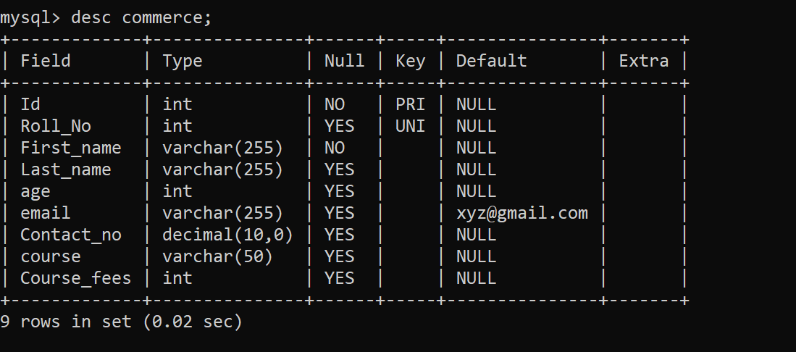

Inserting into commerce course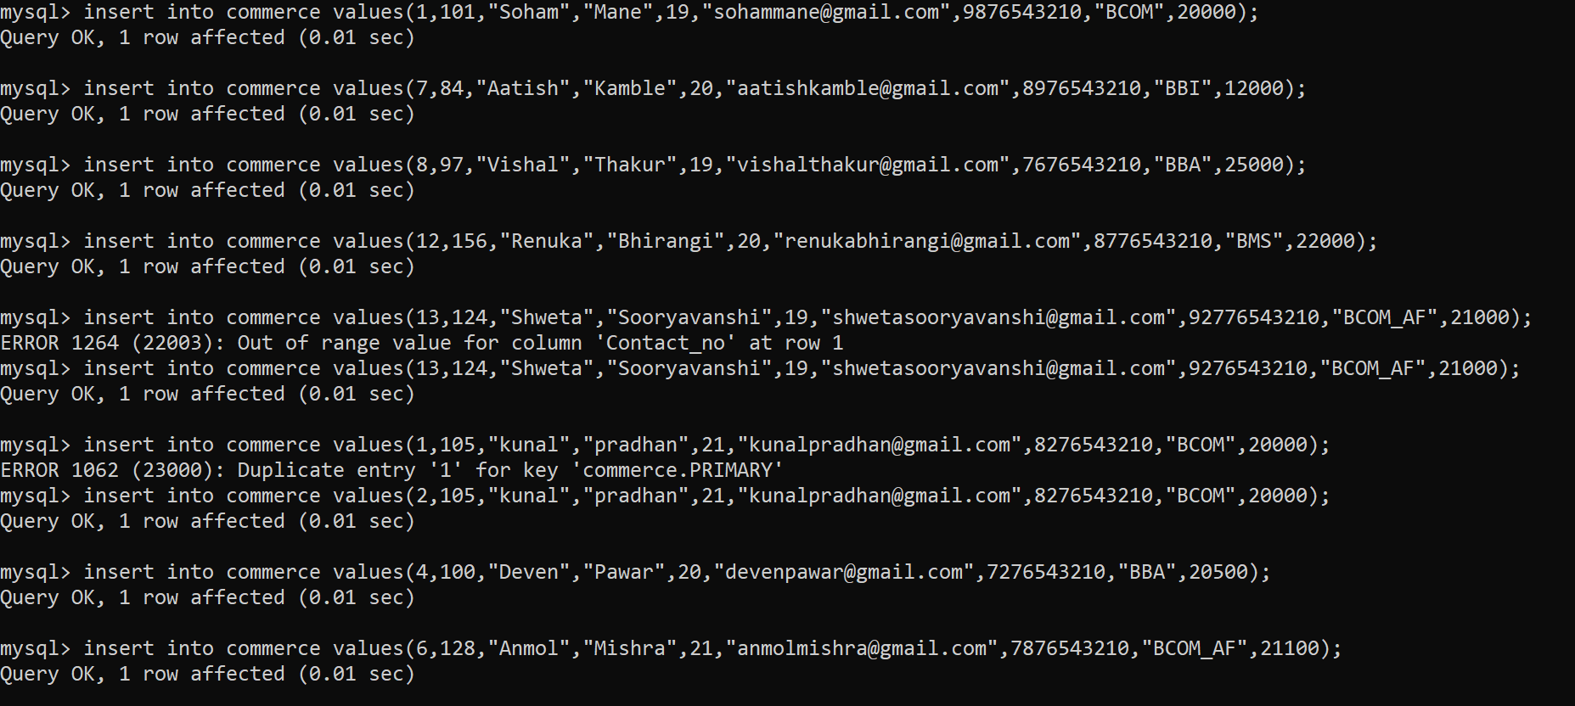

Showing table commerce course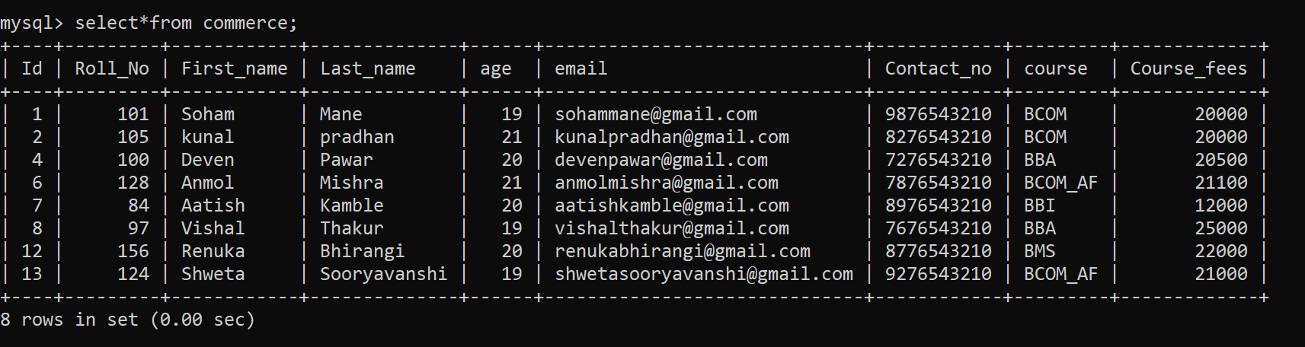

Alter commands:

Adding column 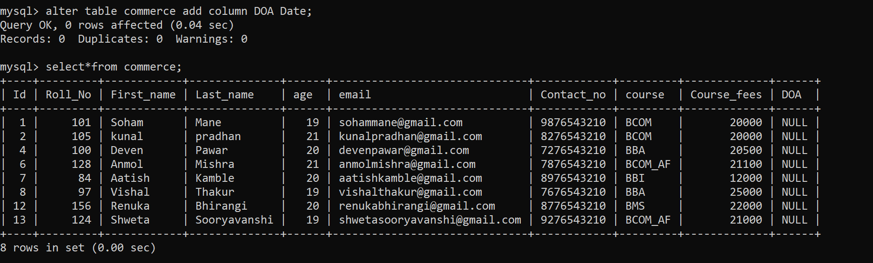

Changing column name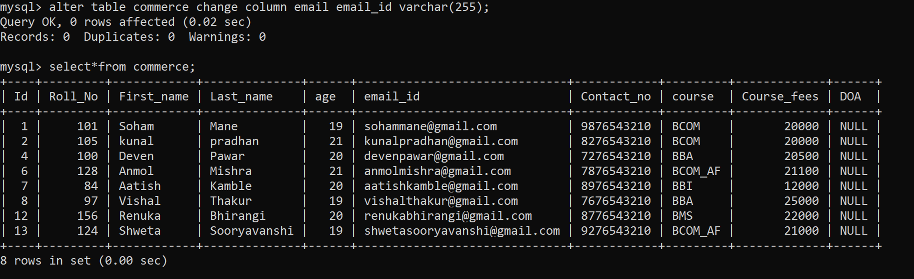

Renaming table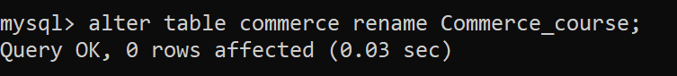

Modifying datatype

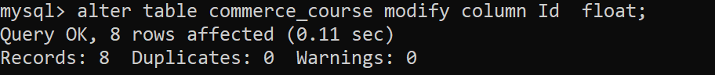

Dropping column

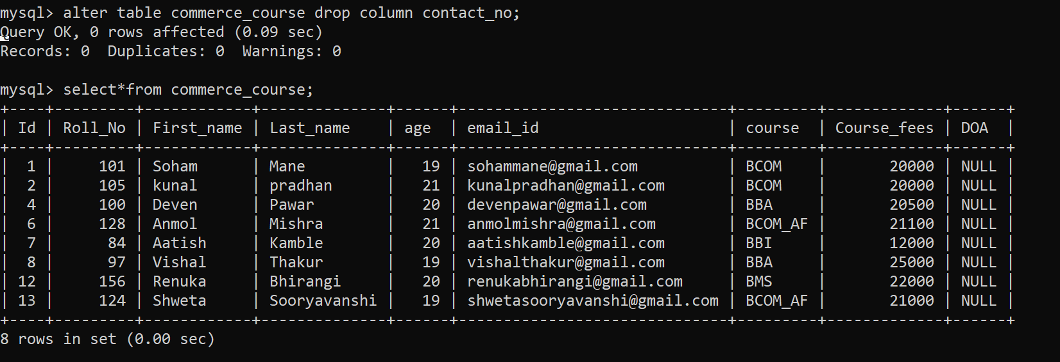

Update commands:

Updating whole column

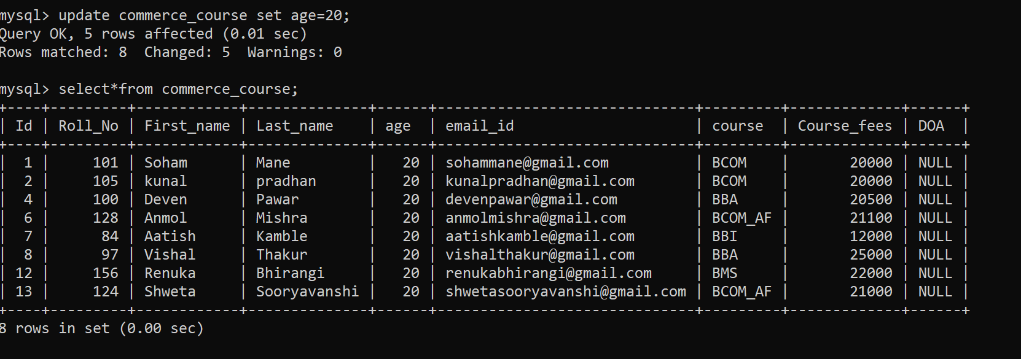

Updating specific row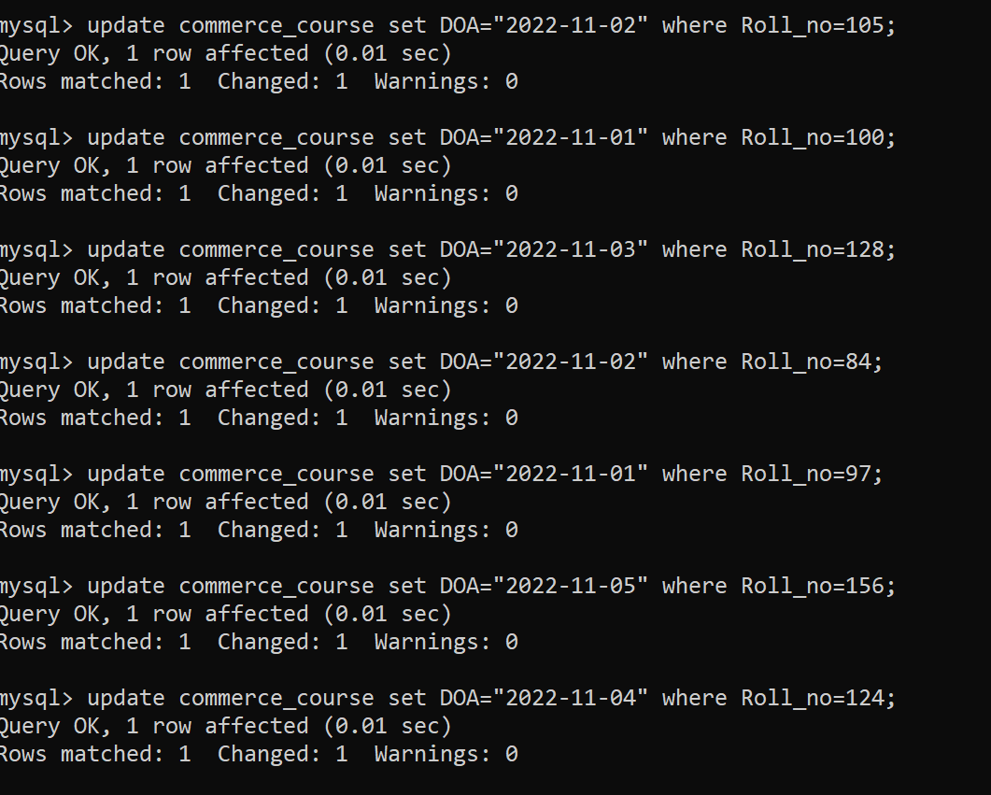Deleting specific row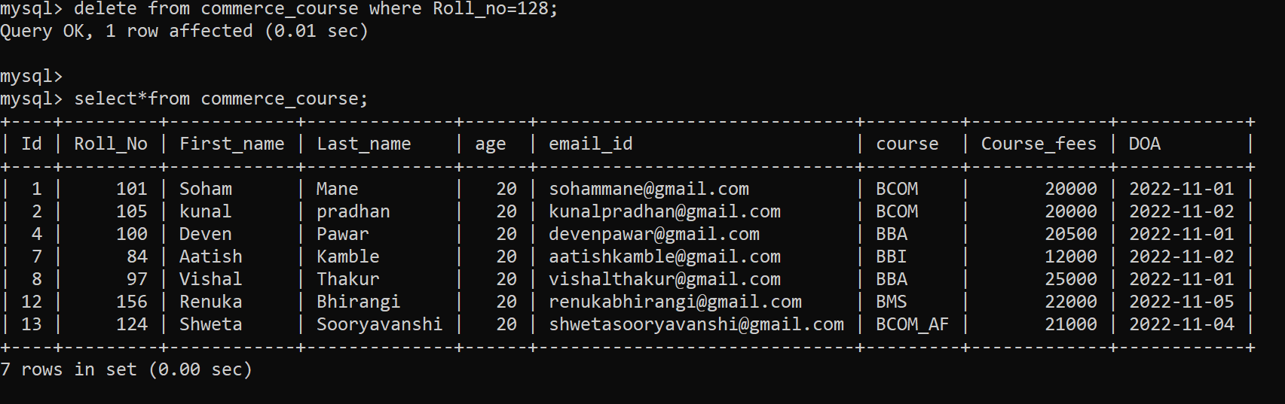

WHERE clause with AND operator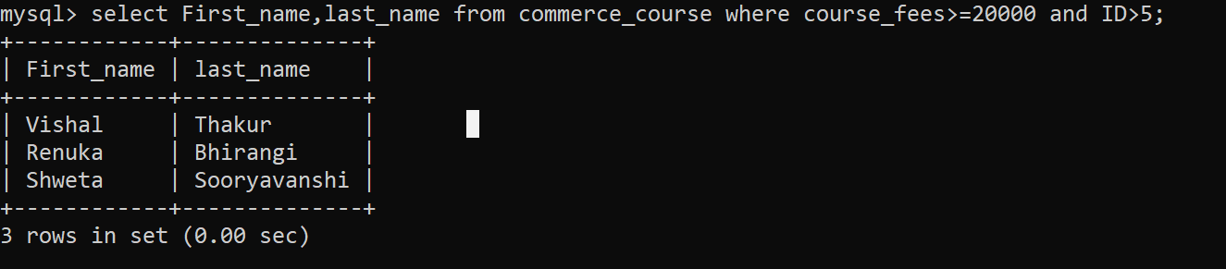

WHERE clause with OR operator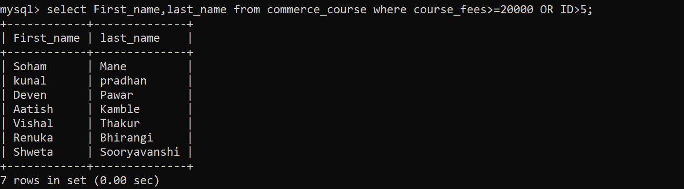

WHERE clause with BETWEEN operator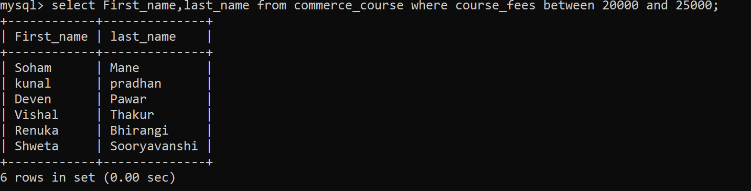

WHERE clause with IN operator 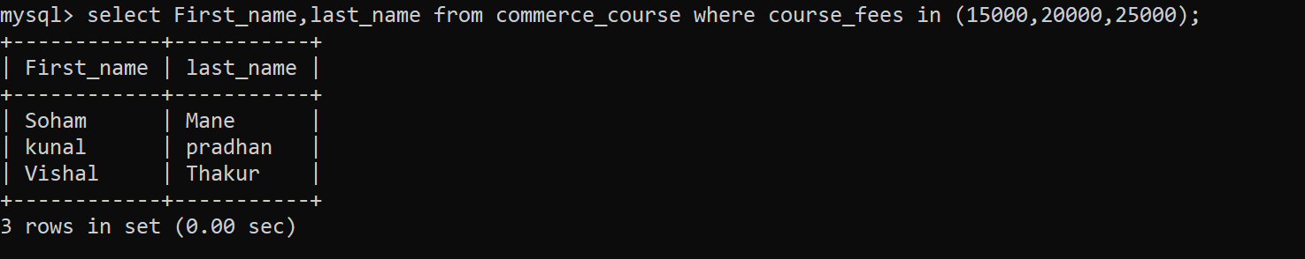

WHERE clause with LIKE operator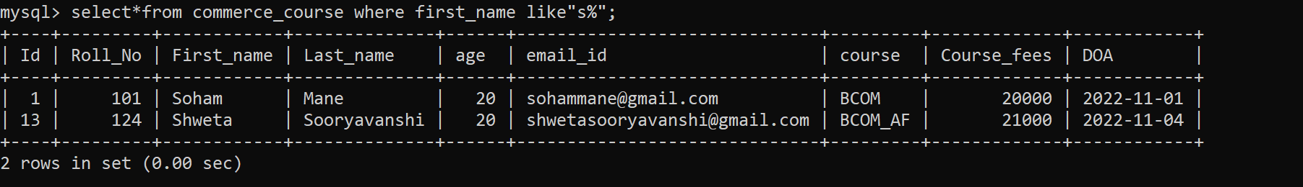

ORDER BY 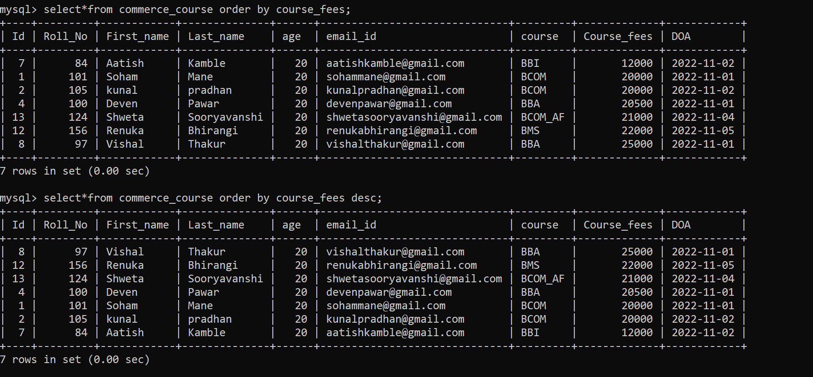GROUP BY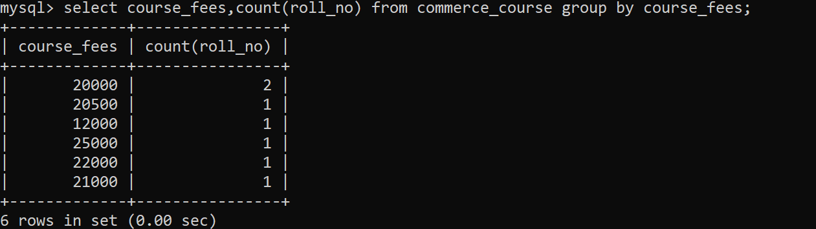GROUP BY with ORDER BY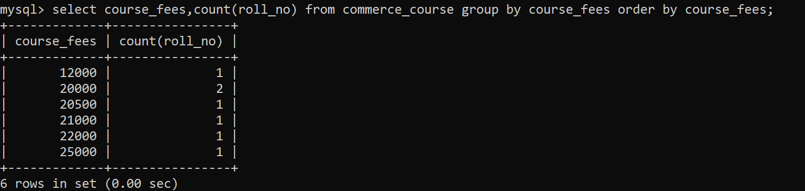

SQL Functions

1.STRING FUNCTION

CONCAT STRING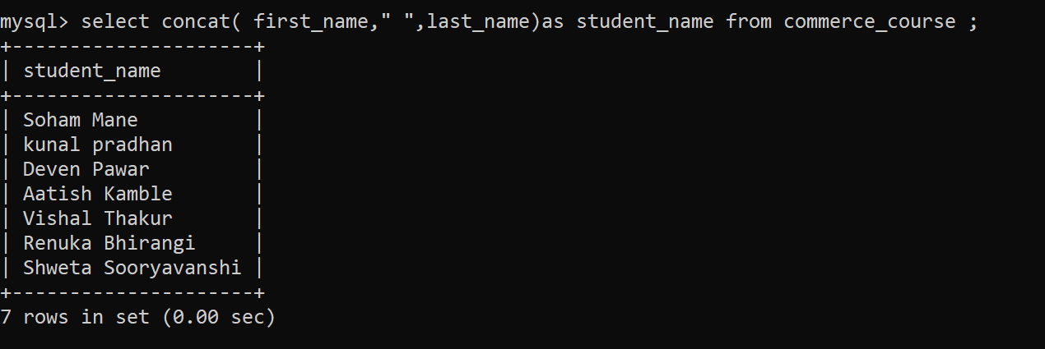

LOWER STRING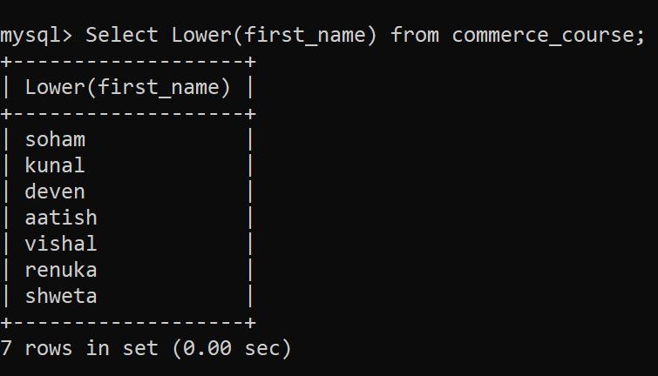

SUBSTRING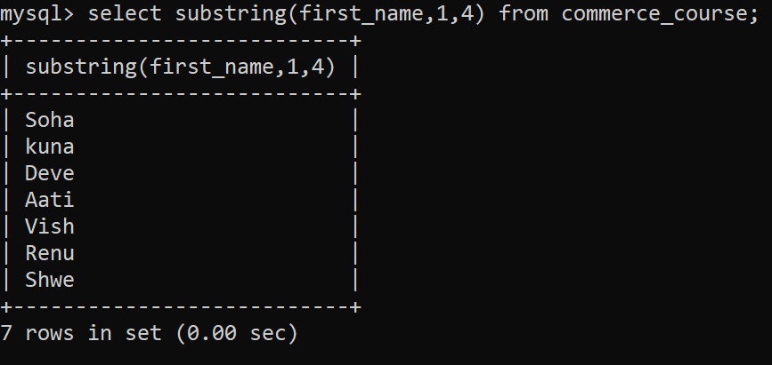

2.MATH FUNCTIONS

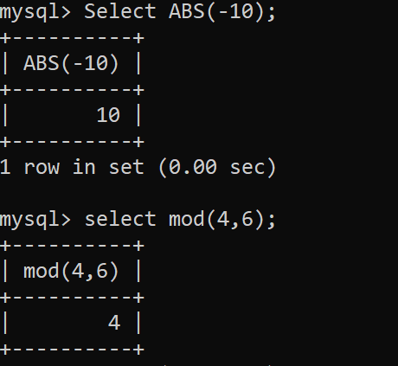

3.DATE FUNCTIONS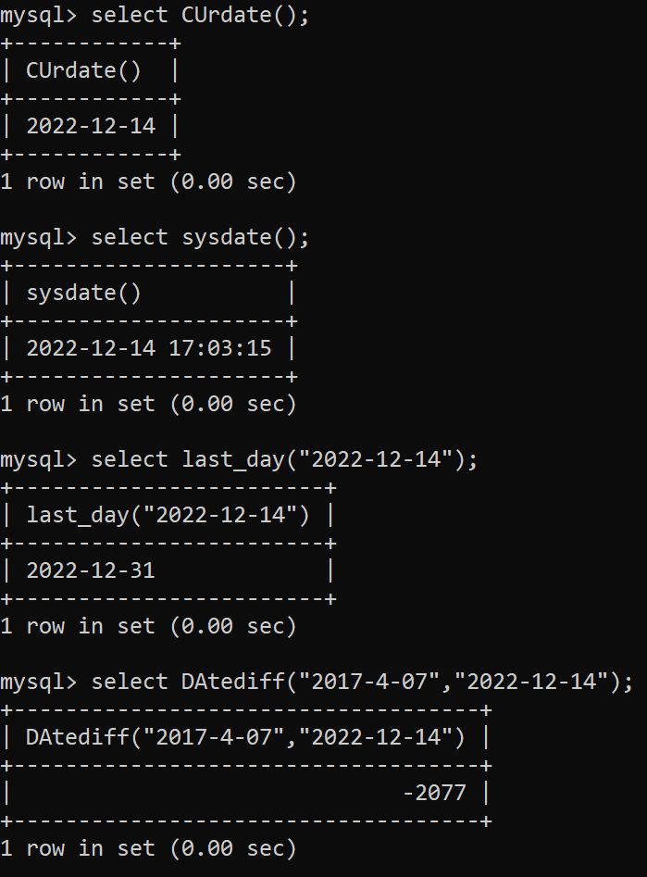

4. AGGREGATE FUNCTIONS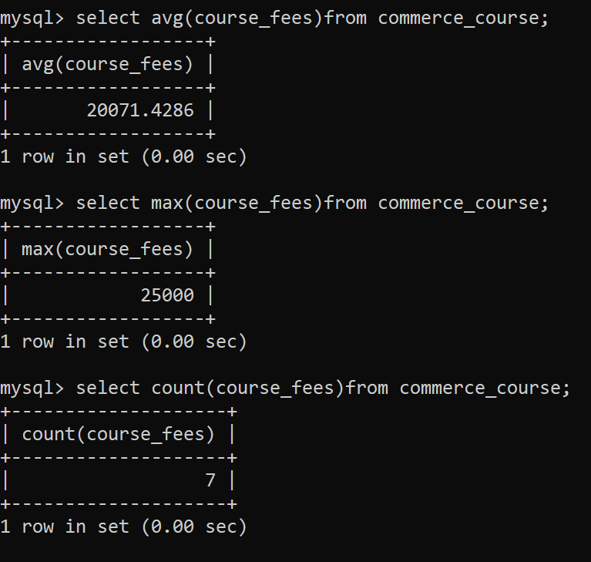

Adding Foreign key and creating table Fests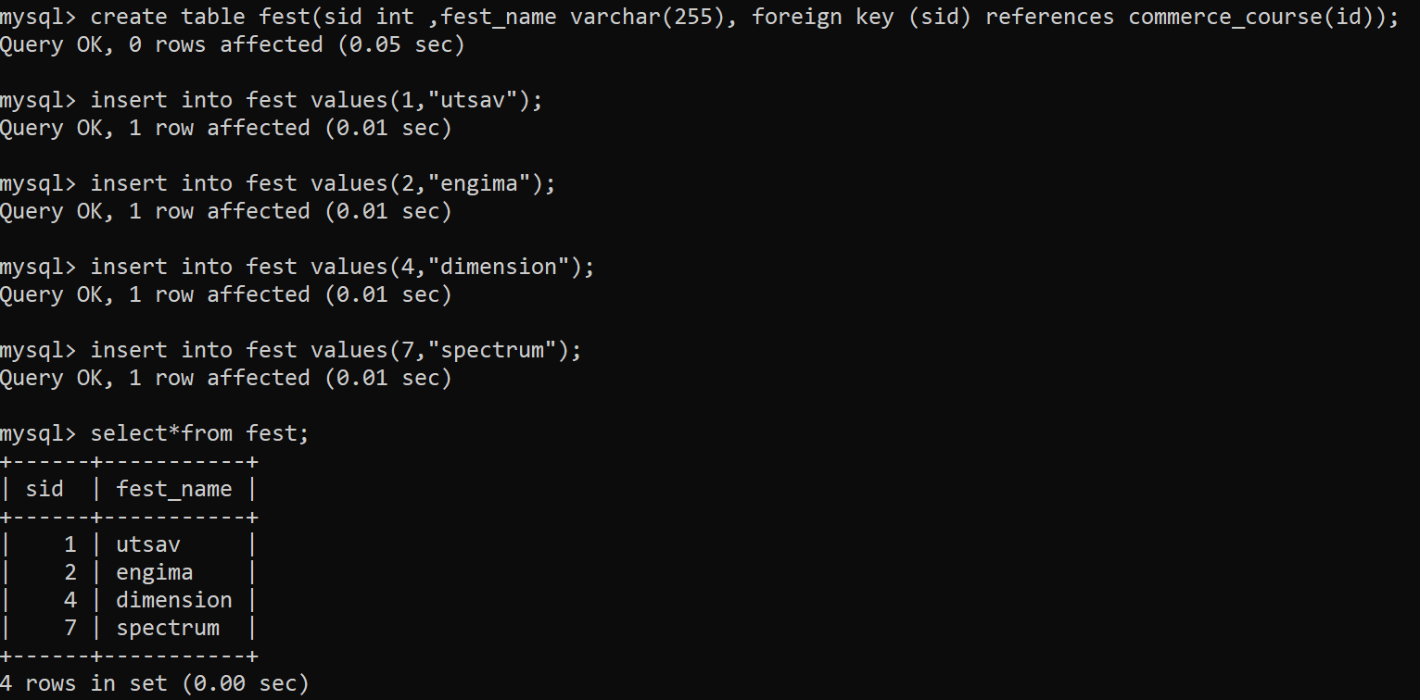

Creating table Sports dayShowing table Sports day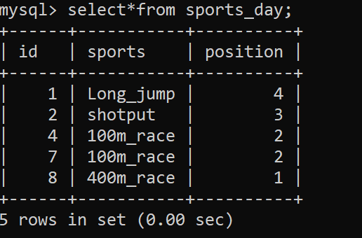

INNER JOIN (to get list of commerce students playing sports)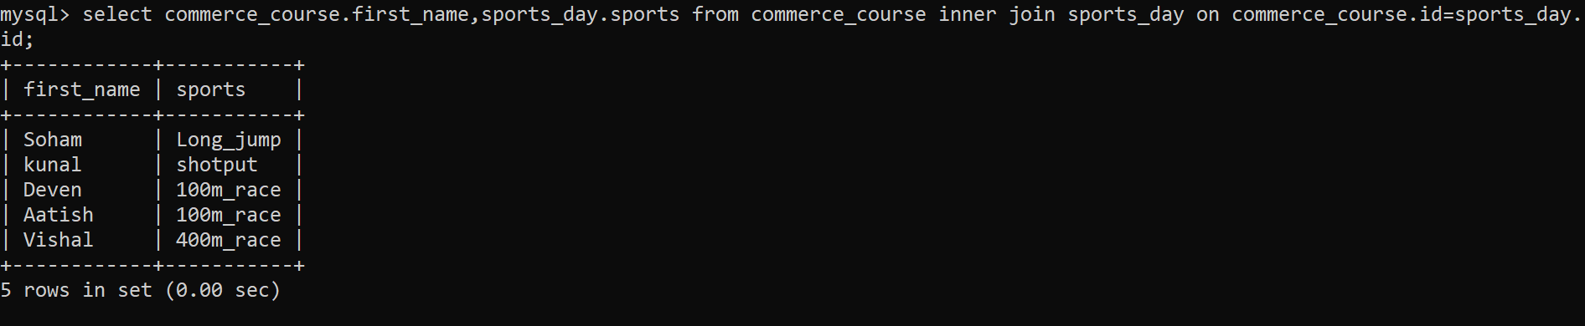

LEFT JOIN (to get list of all commerce students playing all sports)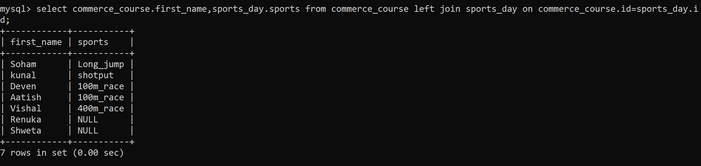

RIGHT JOIN (to get list of sports played by commerce students)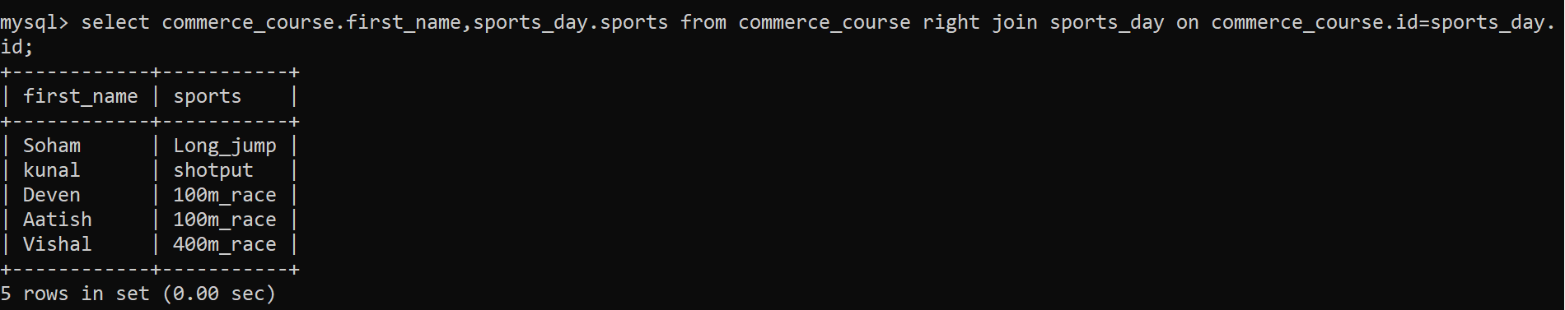

FULL OUTER JOIN (to get list of all the commerce students playing sports)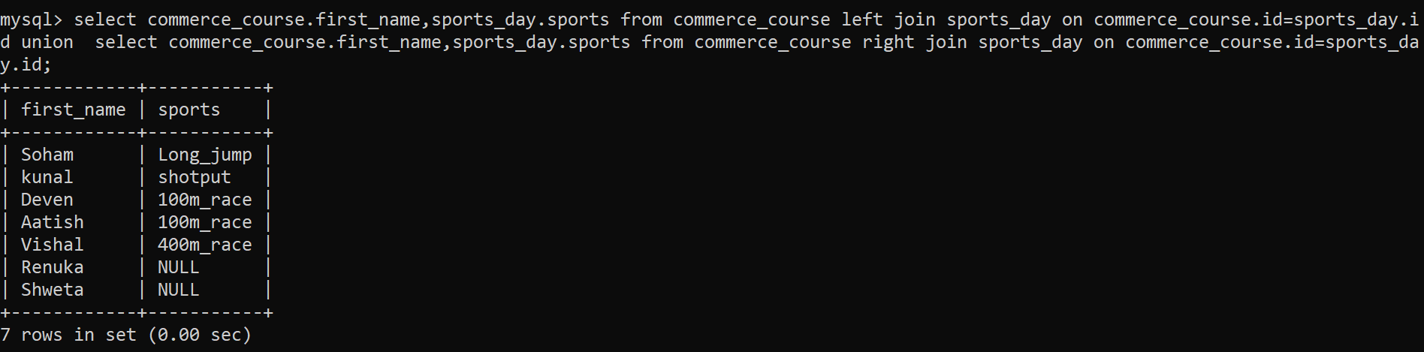

SELF JOIN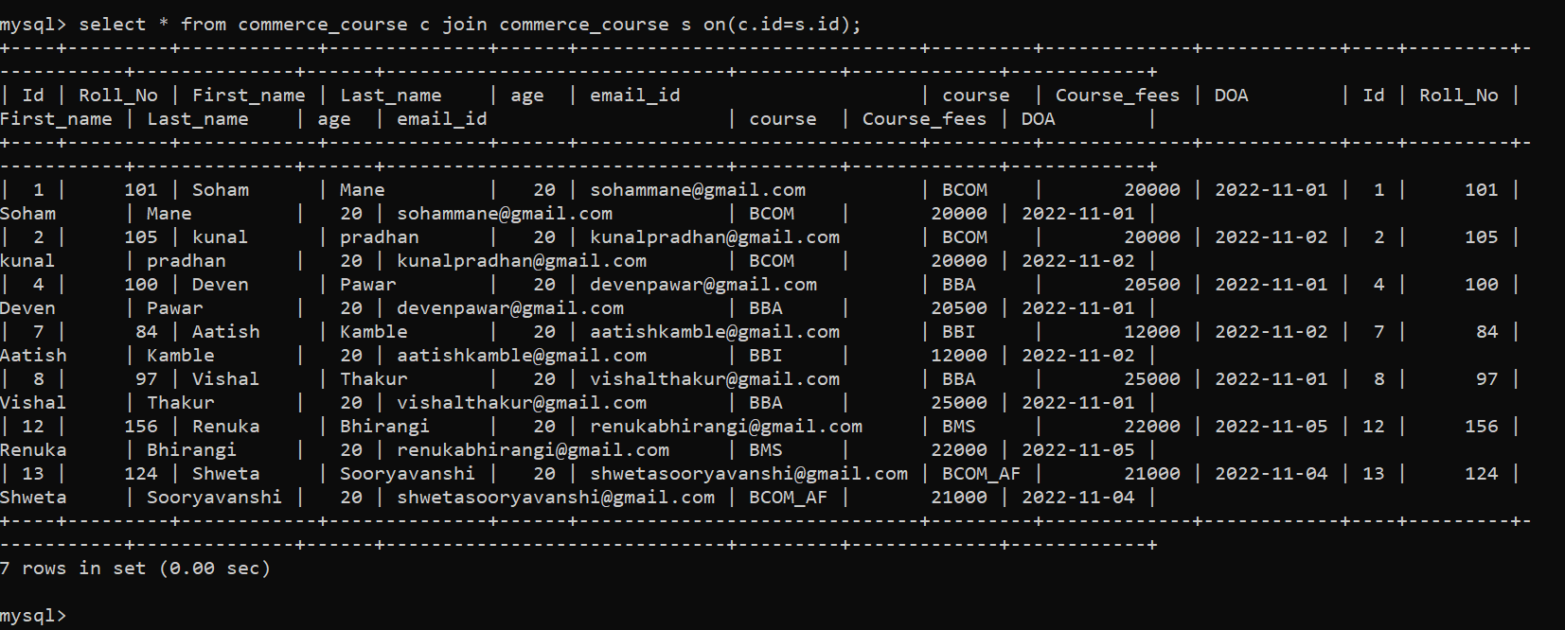

SUBQUERIES

Subquery to find out course fees less than maximum score fees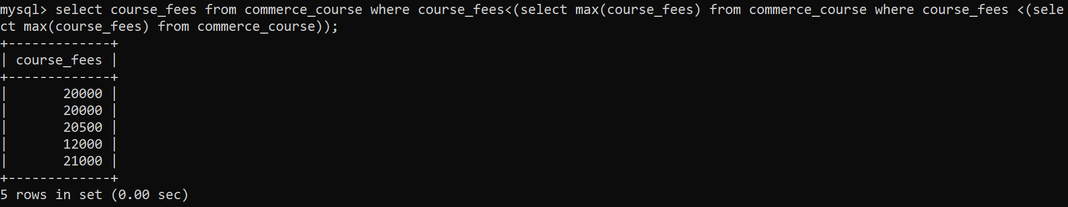

SUBQUERY with IN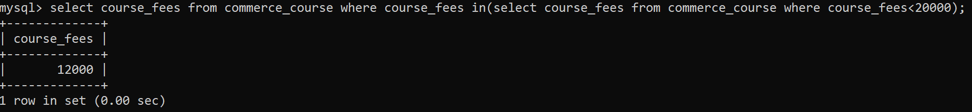

SUBQUERY with ALL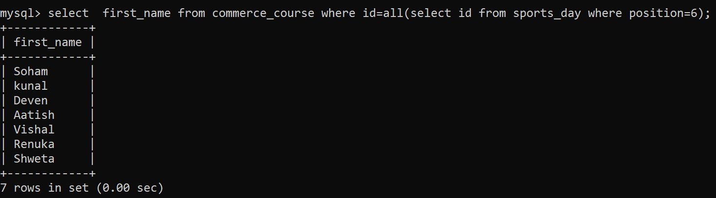

SUBQUERY WITH ANY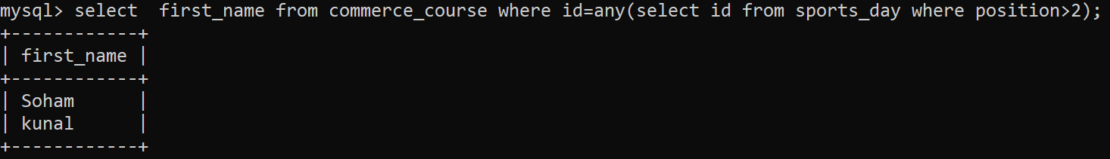

SUBQUERY WITH <ALL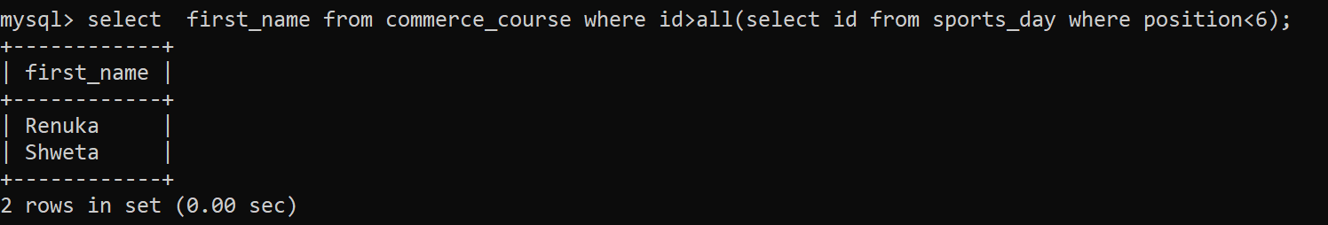

Creating VIEW